Testing Procedures

Distributed Fence Vibration Monitor System

Version 1.2

Prepared by

L. Marin

Embry-Riddle Aeronautical University

Table of Contents

1 Introduction 3

2 Requirments 3

3 Acceptance Tests 3

3.1 Purpose 3

3.2 Test Case List 3

3.3 Test Requirements Matrix 4

3.4 Required Equipment (will update with actual product names) 4

3.5 Test Setup (MKR1310) 5

3.6 Test Setup (Accelerometer) 6

3.7 Test Setup (Lithium Battery) 7

3.8 Test Setup (Software) 8

4 References 9

# Introduction

This document will go over several tests run on the product by the ERP team, to verify certain parts of the design before turning in a completed prototype.

# Requirments

|  |  |
| --- | --- |
| **ID** | **Requirments** |
| ER-1 | The electrical characteristics of the microcontroller and battery shall adhere to the following table.   |  |  |  |  |  |  | | --- | --- | --- | --- | --- | --- | | **PARAMETER** | **TEST CONDITIONS** | **MIN** | **TYP** | **MAX** | **UNIT** | | Battery Supply Voltage |  | 5 |  | 7 | V | | CPU & I/O Voltage |  | 1.62 | 3.3 | 3.63 | V | | Supply Current | Mode: Sleep |  | 104 |  | µA | | Mode: Processing |  | 6 |  | mA | | Mode: Transmitting |  | 128 |  | |
| ER-2 | The electrical characteristics of the accelerometers shall adhere to the following table.   |  |  |  | | --- | --- | --- | | **Accelerometer Device** | **Current at Nominal Voltage** | **Estimated Power** | | ADXL355 | 200 µA at 3.3V | 0.66 mW | | ADXL345 | 130 µA at 2.5V (100Hz sampling) | 0.364 mW | |
| HR-1.1 | The minimum self-powered time (no servicing) for viability is 48 hours. |
| SR-1.2 | The server shall receive information from an arbitrary number of nodes. |
| SR-1.3 | The server shall record the data transmitted from the nodes. |

# Acceptance Tests

## Purpose

The purpose of these tests is to verify conformance to the design. All tests will be performed indoors in a lab unless specified otherwise.

## Test Case List

|  |  |
| --- | --- |
| **ID** | **Test Case** |
| TC-1 | Verifies the power levels of the MKR1310 microcontroller |
| TC-2 | Verifies the power levels of the two accelerometer options |
| TC-3 | Verifies the power levels of the batteries |
| TC-4 | Verifies that the ISR is working properly |
| TC-5 | Verifies that the nodes can send and receive data |

## Test Requirements Matrix

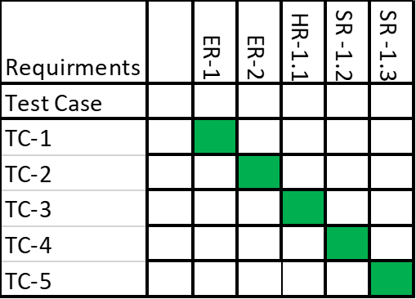

## Required Equipment

1. Power Supply
2. Oscilloscope
3. Tektronix TCP2020
4. Multimeter
5. Jumper Wires

## Test Cases

**TC-1**

|  |
| --- |
| Purpose/Description:  To verify that the MKR1310 microcontroller electrical specifications are within tolerance. |
| Stimulus:   1. Set the power supply to 6 volts. 2. Connect a current probe to one of the oscilloscopes channels and put the probe around the positive lead. 3. Connect another oscilloscope probe to pin six, the indicator pin, of the MKR1310. 4. Degauss the current probe. 5. Connect the power supply to the microcontroller. 6. Run test_2.cpp to cycle through all levels of transmission power. 7. Measure the current draw for each of the different transmission powers 17 in total. 8. Repeat steps a through f for the remaining microcontrollers. 9. Verify that the measured data is what was expected, which should be different peaks for each transmission strength. |
| Validation:  The MKR1310 currents had a min of 18mA and a max of 111mA. |
| Requirments Being Tested:  ER-1 |

**TC-2**

|  |
| --- |
| Purpose/Description:  To verify that the ADXL and MPU accelerometer electrical specifications are within tolerance. |
| Stimulus:   1. Set the power supply to 3.3 volts. 2. Attach the power supply to the accelerometer. 3. Record the measured current value. 4. Verify that the measured data is what was expected for each sensor. |
| Validation:  The ADXL had an average current draw of 0.0223mA and the MPU had an average draw of 1.667mA |
| Requirments Being Tested:  ER-2 |

**TC-3**

|  |
| --- |
| Purpose/Description:  To verify that the battery voltages are within tolerance. |
| Stimulus:   1. Probe the battery leads with the multimeter. 2. Measure both voltage and current from the battery. 3. Verify that they are correct for each battery. |
| Validation: |
| Requirments Being Tested:  HR-1.1 |

**TC-4**

|  |
| --- |
| Purpose/Description:  To verify that the ISR can be triggered in both sleep and wake modes |
| Stimulus:   1. Place the board on a flat stable surface. 2. Turn the board on. 3. While the board is in sleep mode, tap the board in a way that would trigger the ISR. 4. Confirm that the interrupt pin on the accelerometer went high. 5. Repeat steps c-d when the board is in wake mode. |
| Validation: |
| Requirments Being Tested:  SR-1.2 |

**TC-5**

|  |
| --- |
| Purpose/Description:  To verify that the module can send and receive data |
| Stimulus:   1. Place the board on a flat stable surface. 2. Send data to a board and have the array values printed out. 3. Verify that the values are the same as those that were transmitted. 4. Have the board send data to another board and verify that the receiving board is receiving. 5. Print the array values and verify that the values are the same as those that were transmitted. |
| Validation:  Both the sent and received arrays were the same. |
| Requirments Being Tested:  SR-1.3 |

# References

Lets do references in IEEE format. Use word’s built in manager